26 February 2018

Candidates Name
Candidate for Batman

Dear Candidates First name,
Request for a Public Statement on the recent action by La Trobe University to terminate its lease with Strathallan Golf Club covering the golf course land and utilise the land for an alternative purpose.

Some 30 years ago the local community stage a successful campaign, over a 10 year period to retain the land currently occupied by the Strathallan golf course and Public walking track. The golf course and walking path provides an invaluable buffer to significant flora and fauna sanctuaries including the Gresswell Forest Reserve, Gresswell Habitat Link, Gresswell Hill Reserve and La Trobe University Wildlife Sanctuary.

The Save Strathallan, Open Space Community Coalition, was formed after notice was given to the Strathallan Golf (operating since 1957) that its landlord La Trobe University intended to terminate the golf club’s lease as of the 1st January 2019 and (initially) seek to re-zone the area for residential development.

This has outraged the local community and the Golf Club members; we seek confirmation from you, if elected to seat of Batman, that you would view this grab for money by La Trobe University as abhorrent to your Party’s principles, to take a “community asset” from local residents primarily to secure a multi-million financial gain, ignoring the terms the land was acquired under by the University, (please see attached document). Also, we seek your support in restricting any future Federal Government funding to La Trobe University, until this matter is resolved, on the basis of their hypocritical attitude to the local community.

The Save Strathallan, Open Space Community Coalition, has collected almost 5000 signatures in a petition from local residents, golf club members and other people appalled by La Trobe University’s intention to destroy a local amenity. The La Trobe Univesity Council will not receive any representation from our committee or accept our petition. We have received excellent support from our local Victorian State member of parliament Mr Colin Brooks MP, Darbin & Banyule City Councils, local media and the broader Community. However, as the University is funded Federally, we consider a statement expressing repugnance for the sale of this land from you would be exceptionally well received by the local community. We can convey your message of support to the members of the community coalition, the members of the Golf Club and the Springthorpe residents association.

If you have any queries on ths matter please contact me on 0488 246833.

Yours sincerely
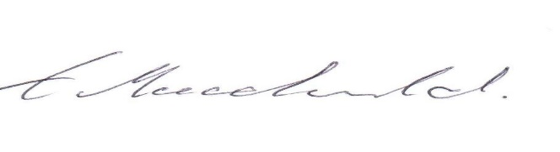
Owen Macdonald
Save Strathallan Open Space Community Coalition Inc.

